

***A newsletter of the ACE DisAbility Network* June 2013**

**Supported by** **

**News**

***Contents***

News 1

Defining Inclusion 2

Barriers to Inclusion 3

Inclusion Tips 3

Power of Inclusion 4

The best recent news is the passing of “Disability Care” (formerly known as the NDIS) into law, which means that there should be more money to support the needs of people with disability in the future. We will keep you posted on the progress and timelines of this in coming newsletters and discuss the possible impacts for you/your centre.

**ACE DisAbility News**

Most of you will have received our revised timetable for the next six months (if not drop us an email and we will send you out one). The first half of this year we found that we were so busy, we had to prune our timetable in order to fit everything in – hence a much shorter version for this six months concentrating on **Learning and Teaching People with Cognitive Disability** and **Managing Volunteers with Disability**. However, we are still running courses tailored to order on ***any topic involving disability***, so if you are interested in running a workshop amongst your network or at your centre, give us a call.

Affordable Video Production & Duplication Services

Challenge Multimedia provides low cost professional

•video production & editing

•duplication & associated services

Give your application, website or function the edge by showing film or digital pictures to tell a story.

Ph: 9916 5834 or email [michael.christofas@yooralla. com.au](mailto:michael.christofas@yooralla.%20com.au)

Challenge Multimedia is a Yooralla enterprise that supports people with disabilities…

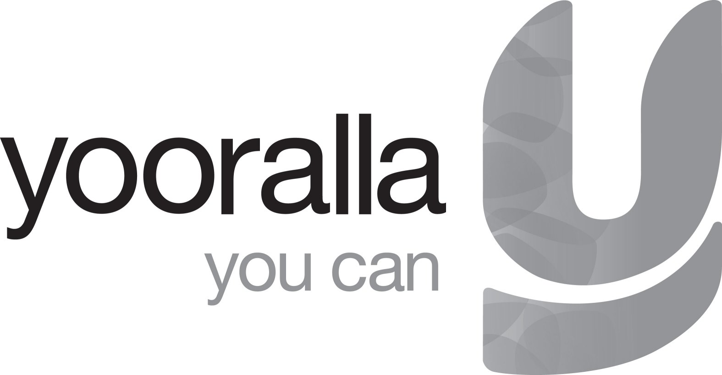

As well as running training workshops, Olympia and Judy have also been involved in Yooralla’s “Speaking Up” program, which aims to teach people with disability how to recognise abuse and how to deal with it when they do encounter it and most importantly how to “speak up”. This new program is being trialled now but plans are to expand its availability to other people with disabilities across the sector. If you are interested in learning more about this program, please let us know.

**This issue**

In this edition we are talking about **inclusion** in general. Although most of us these days are aware of what inclusion means, it does still tend to get confused with integration which is just the physical presence of people with disability at our centres rather than the equal participation of people with disabilities at our centres either as: learners, volunteers or even committee members.

C:\Documents and Settings\judy.buckingham\Local Settings\Temporary Internet Files\Content.IE5\NK2F0M65\MC900197723[1].wmf.

**Understanding inclusion**

**What do we mean by inclusion?**

Inclusion is the process whereby every person (irrespective of age, disability, gender, religion, sexual preference or nationality) who wishes to ***can access and participate fully in all aspects of an activity or service in the same way as any other member of the community.***

Inclusion requires time, space, effort and resources but it creates a society which is:

* Fairer
* More cohesive
* Richer
* More diverse

## Inclusion vs. integration in education provision

Inclusion is often confused with integration. In an educational setting for example, integration means ***only the physical presence*** of a person with a disability. This often means people with a disability are placed in specialised classes or groups quite separate to mainstream classes. It can also mean a person with a disability being in a mainstream class but having a separate program or not enjoying the same social and learning outcomes as other class members.

Inclusion is:

* More than just presence
* Making an effort
* Knowing something about disability and individual impairment
* Balancing values: the community’s, your own, people with disability
* A co-ownership of space
* Understanding individual needs.

Inclusion is not:

* Something only certain people do, everyone needs to be involved
* Something that is ever completed. We always have to work at it. People change and so do values and conditions, one person with a disability cannot be assumed to be the same as another, like everyone else they are individuals.

**Barriers to inclusion**

We are creating barriers to inclusion when:

* We make assumptions about people with disability
* We do not fully involve someone (i.e. allow just a presence)
* We shield individuals or groups to protect them, often unnecessarily
* We do things for people that they can either do for themselves or haven’t asked us to do for them.

We are supporting inclusion when:

* We challenge our assumptions and values
* We are willing to overcome our discomfort
* We learn to embrace differences
* We recognise that people express themselves differently
* We advocate and support the public to be more tolerant.

## Inclusion tips for ACE providers

* 1. Be open and welcoming to all. Reflect this in all your policies and practices – which should be accessible and on view

* 1. Discuss the individual’s needs and expectations with them personally
  2. Obtain disability awareness training for yourself, your committee of management, your volunteers and all your staff, whether or not they teach people with a disability. Contact your local council or the ACE Disability Network for information on how to find suitable training
  3. Gather resources: publications such as PALS (Inclusion Melbourne), The Inclusive Communities Manual (ANHLC) have been developed specifically for adult education providers
  4. Develop partnerships with others that support inclusive practices such as local disability organisations
  5. Invite people with disability as full participating members onto your committee of management, and other planning and decision making forums, remembering that they might have support needs
  6. Locate local community supports e.g. Metro and Rural Access Workers at your local council offices and network with them regularly
  7. Access the support and assistance provided by the ACE Disability Network
  8. Develop a Disability Action Plan which includes inclusive practices and access and commit to implementing it
  9. ***Above all, attitude can be the greatest barrier to inclusion which often requires a creative shift in thinking rather than large financial expenditure***

**The power of Inclusion**

Earlier we listed the possible advantages of Inclusion, but we now know that Inclusion can have both practical and overall benefits for all of us.

* Power of Inclusion for the Person with a Disability

I have seen people who previously lived a life where exclusion and discrimination were the norm who now live fuller, more valued and happier lives, able to enjoy more leisure, friendships and improved health. This is the potential positive impact of full Inclusion.

When people are given the opportunity to learn and to explore or develop their skills/abilities and relationships the snowball effect of this can also improve the lives of others. e.g Family, carers, friends.

Technology and access to Multimedia is one great way to remove barriers and assist people to be included in the Digital Age and participate in ways that able–bodied people currently do. Teaching or learning the skills to enable someone this, is an invaluable example of how to do this.

* Power of Inclusion for staff

Even though Inclusion takes effort, as mentioned earlier, the benefits to staff in terms of their learning and development can be lifelong and may be called upon at any time. E.g. for family or personal matters or in another work role.

Also, whatever staff learn through the process of supporting someone to be included can be modelled or mentored for others and as such the culture of “inclusiveness” of a service can begin to emerge where previously not. This means that such a centre would be more likely to have a Disability Action Plan or be more in line with its statutory obligations under the Education Standards for Disability 2005 and the Federal Disability Discrimination Act.

* Power of Inclusion for the Community/Society

As you are aware the Federal Government has just passed legislation to provide both greater financial support of people with serious and lifelong disability via the DisabilityCare Australia program. This commitment was made with the rationale that we will all be better off by a scheme that aims to give people with a disability greater choice, flexibility and support to lead fuller and more inclusive lives.

The government says this is not only a moral obligation and a human rights issue but one that recognises greater participation by people with a disability will not only promote a richer, more cohesive and fairer society but also yield economic benefits as more people with disabilites become more independent, are better educated and purchase more goods and services with the additional funds they will receive. They also expect approximately 150,000 new jobs to be created directly by the new scheme.

Inclusion is powerful indeed!!